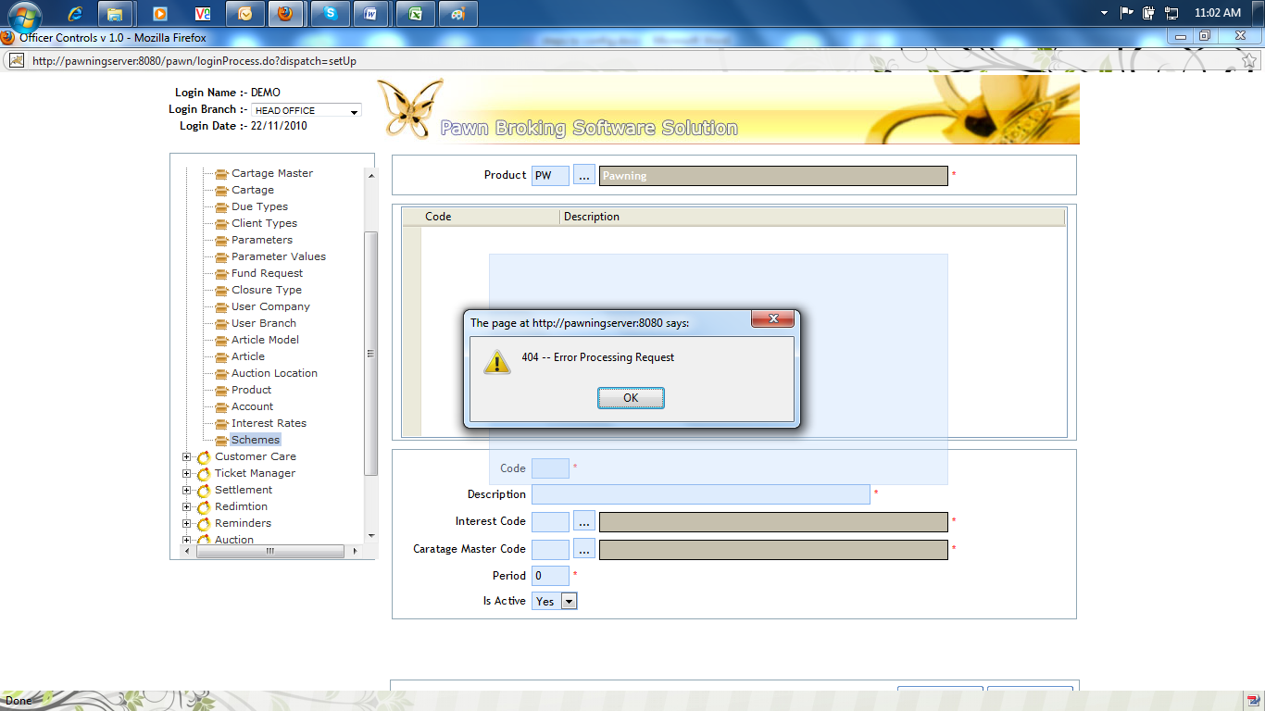
1. Select the “Pawning” as default
2. How to update Fund Available amount currently shows as 200173/=. how this value pick. shows at "User Branch" and "Fund Request"
3. What is fund request and why it is in sysConfig. No button display. (enable scroll bar)
4 No closure type displayed
5 increase the ledger code length up to 9 digits if it is manual update . (easy to link with inbank)
6. Error at schemes
7. Set “pawner” as default value for the main client
8. Update Percentage according to the Disburse Value
9 dual authorized for caratage and interst rate change.

